# Real-World Use Cases of Consumer Functional Interface

## Introduction

In this tutorial, we will implement **real-time use cases** using the **Consumer Functional Interface** in Java 8.

## Setting Up the Data

1. A new package named **data** is created.

2. The package contains two classes:

- **Student**: Contains four properties: `name`, `gradeLevel`, `GPA`, and `gender` with appropriate getter, setter, and `toString()` methods.  
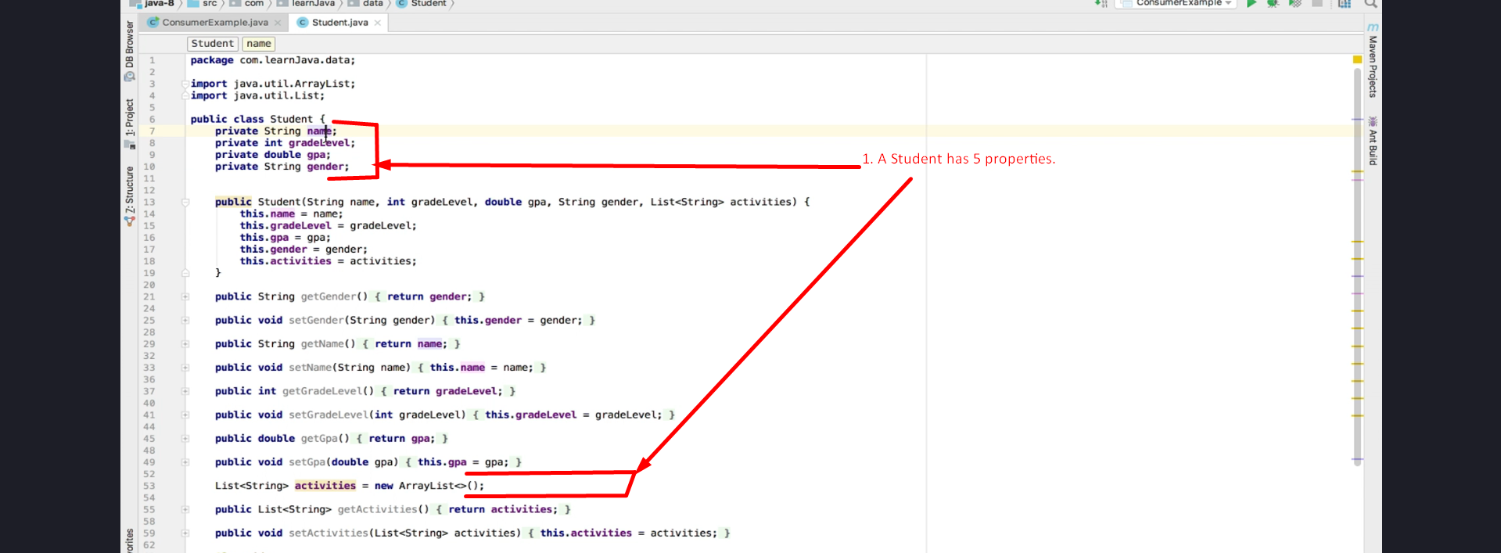

- **StudentDataBase**: Contains a static method `getAllStudents()` that returns a list of six students (two from each grade level: 2nd, 3rd, and 4th).  
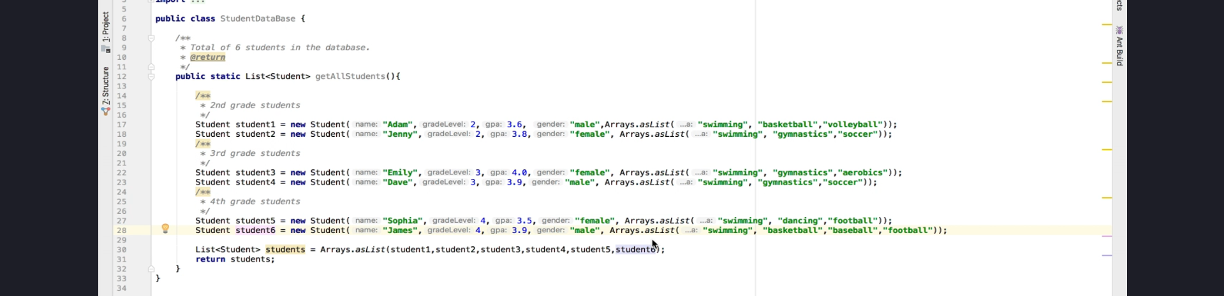

## Implementing Consumer Functional Interface

1. A new class **ConsumerExample** is created to demonstrate the use of the **Consumer Functional Interface**.

2. The method **printName()** is created to iterate over and print the names of students.

## Using forEach() Method

- Java 8 introduced **forEach()**, a **default method** in the `List` interface.

- It accepts a **Consumer Functional Interface** as an argument.

- Instead of using an enhanced `for` loop, we use `forEach()` to iterate through student data.

## Implementing Consumer Using Lambda

1. **Consumer<Student> c2** is created to print each student's details using `toString()`.

2. The `forEach()` method accepts `c2`, which prints all students from `StudentDataBase`.

### **Code Implementation:**

public class ConsumerExample {  
 public static void main(String[] args) {  
 List<Student> studentList = StudentDataBase.getAllStudents();  
  
 Consumer<Student> c2 = (student) -> System.out.println(student);  
  
 studentList.forEach(c2);  
 }  
}

## Printing Student Name and Activities

1. **Method printNameAndActivities()** is created to print student names and activities.

2. Each student has a **list of activities** such as `swimming, basketball, volleyball`.

3. Two separate consumers are created:

- **c3**: Prints the student's name.

- **c4**: Prints the student's activities.

4. The **andThen()** method is used to **chain** consumers to print both name and activities in one execution.

### **Code Implementation:**

Consumer<Student> c3 = (student) -> System.out.print(student.getName() + " - ");  
Consumer<Student> c4 = (student) -> System.out.println(student.getActivities());  
  
studentList.forEach(c3.andThen(c4)); // **Consumer Chaining** to print student’s name and activities.

## Filtering Students Based on Grade

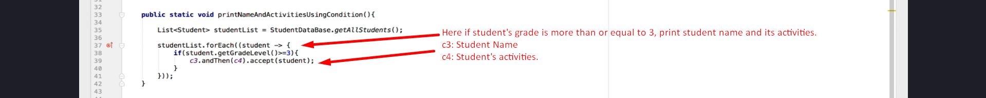

1. A new method **printNameAndActivitiesUsingCondition()** is created.

2. Students with a **grade level of 3.0 or higher** are filtered.

3. Instead of duplicating code, a **Lambda expression** is used within `forEach()` to filter students before printing.

4. The reusable consumer **c3** (printing names) is used to avoid code duplication.

### **Code Implementation:**

studentList.forEach(student -> {  
 if(student.getGradeLevel() >= 3) {  
 c3.accept(student);  
 c4.accept(student);  
 }  
});

## Filtering Based on GPA and Grade Level

1. A new condition is added to filter students with **GPA >= 3.9**.

2. The same consumer `c3` is reused to print the names of selected students.

### **Code Implementation:**

studentList.forEach(student -> {  
 if(student.getGradeLevel() >= 3 && student.getGPA() >= 3.9) {  
 c3.accept(student);  
 }  
});

## Need for Predicate Functional Interface

1. If multiple conditions need to be applied dynamically, **Predicate Functional Interface** is a better alternative.

2. Instead of duplicating filtering conditions, **Predicate** can encapsulate the logic.

3. This will be covered in upcoming tutorials.

## Chaining Multiple Consumer Interfaces

1. We previously used **andThen()** to chain two consumers.

2. Java allows chaining **N number of Consumer Functional Interfaces** using `andThen()`.

3. This feature helps perform multiple operations sequentially.

## Conclusion

- Java 8 introduced powerful functional interfaces like **Consumer** to simplify operations on collections.

- The **forEach()** method, introduced in Java 8, takes a **Consumer Functional Interface** as input.

- We implemented real-world use cases to **filter**, **print**, and **chain** consumer functions.

- We also saw how **Lambda expressions** help in avoiding **code duplication** and improving readability.

- In the next tutorial, we will explore **Predicate Functional Interface** for advanced filtering.

### **End of Tutorial**

Thank you for watching! Thanks a lot.